# Types of Maintenance Testing - Retest (confirmation), Regression and Impact Analysis

## Retesting (Confirmation Testing)

**# Source**: **Chatgpt (GPT-5-Standard) at [8/12/2025]**

* **Meaning:** Testing a **specific defect** again after it has been fixed.
* **Goal:** Confirm that the exact reported bug is now resolved.
* **Scope:** Narrow — only the **failed test case(s)** are executed again.
* **When:** Immediately after a developer claims to have fixed the defect.
* **Example:**
  + Bug: “Login fails with correct credentials.”
  + Fix: Developer updates the login function.
  + Retest: Tester runs the **same login test case** again to confirm it works now.

## Regression Testing

**# Source**: **Chatgpt (GPT-5-Standard) at [8/12/2025]**

* **Meaning:** Testing **unchanged parts** of the software to ensure that recent changes didn’t break existing functionality.
* **Goal:** Catch side effects of code changes.
* **Scope:** Wide — includes previously working features across the application.
* **When:** After any change — bug fix, update, or new feature — before release.
* **Example:**
  + After fixing the login bug, testers also check **signup, password reset, dashboard, and profile features** to ensure they still work.

## Impact Analysis

**# Source**: **Chatgpt (GPT-5-Standard) at [8/22/2025]**

* **Meaning:** Identifying which parts of the system may be affected by a code change or bug fix.
* **Goal:** Focus testing effort on affected areas to ensure changes do not introduce new defects.
* **Scope:** Variable — can range from a few modules to large parts of the application, depending on the change.
* **When:** Before testing a change, update, or bug fix to plan effective test coverage.
* **Example:** After upgrading a database schema, testers identify that reports, queries, and forms may be affected and focus testing on these modules.

## Key Difference Table

**# Source**: **Chatgpt (GPT-5-Standard) at [8/22/2025]**

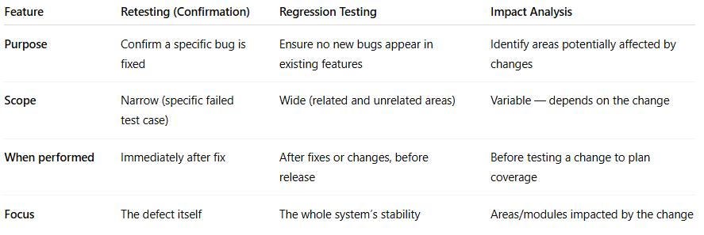

|  |  |  |  |
| --- | --- | --- | --- |
| **Feature** | **Retesting (Confirmation)** | **Regression Testing** | **Impact Analysis** |
| **Purpose** | Confirm a specific bug is fixed | Ensure no new bugs appear in existing features | Identify areas potentially affected by changes |
| **Scope** | Narrow (specific failed test case) | Wide (related and unrelated areas) | Variable — depends on the change |
| **When performed** | Immediately after fix | After fixes or changes, before release | Before testing a change to plan coverage |
| **Focus** | The defect itself | The whole system’s stability | Areas/modules impacted by the change |